SQL to MongoDB Mapping
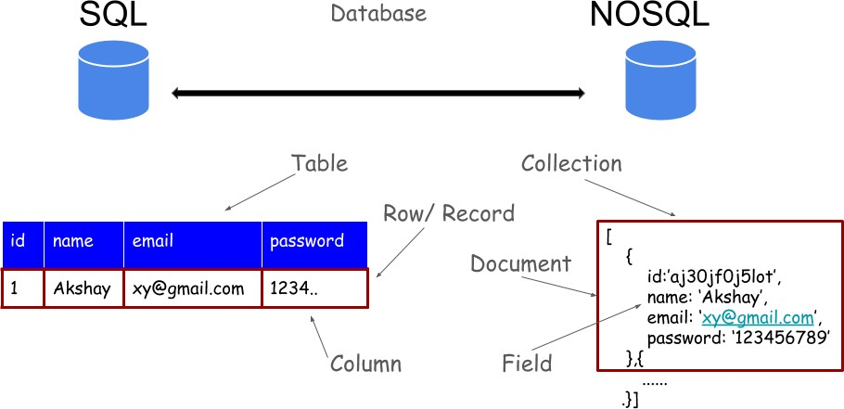
SQL | MongoDB
CREATE TABLE lju (  id MEDIUMINT NOT NULL AUTO_INCREMENT,  user_id Varchar(20), age Number,  status char(1), PRIMARY KEY (id)  ) | db.createCollection(“lju”)  db.insertOne({id:1,user_id:1,age:20,status:A})
ALTER TABLE lju ADD join_date DATETIME | db.lju.updatemany({},{$set:{“join_date
ALTER TABLE lju DROP COLUMN  join_date | Db.lju.updatemany({],{$unset:{“join_date”:””}})
DROP TABLE lju | Db.lju.drop()
INSERT INTO lju (name, age, status)  VALUES (“Test”, 45, "A") | Db.lju.insertOne({name:”Test”,age:45,status:”A”})
SELECT *FROM lju | Db.lju.find()
SELECT id, name FROM lju | Db.lju.find({},_id:1,name:1)
SELECT name, status FROM lju | Db.lju.find({},name:1,status:1)
SELECT * FROM lju WHERE status = "A" | Db.lju.find({status:”A”},{_id:0})
SELECT name FROM lju WHERE status = "A" | Db.lju.find({status:”A”},{name:1})
SELECT * FROM lju WHERE status  != "A" | Db.lju.find({status:{$ne:”A”}},{_id:0})
SELECT * FROM lju  WHERE status = "A" AND age = 50 | Db.lju.find({$and:[{status:”A”},{age:50}]})
SELECT * FROM lju WHERE status = "A" OR age = 30 | Db.lju.find({$or:[{status:”A”},{age:30}]})
SELECT * FROM lju WHERE age > 25 | Db.find({age:{$gt:25}},_id:0})
SELECT * FROM lju WHERE age <= 25 | Db.find({age:{$lte:25}},_id:0})
SELECT * FROM lju  WHERE age > 25 AND age<= 50 | Db.find({and:[{age:{gt:25}},{age:{lte:50}}]})
SELECT * from lju where name=”abc” and age=20 | Db.find({and:[{name:”lju”},{age:20}]})
SELECT * FROM lju  WHERE status = "A" ORDER BY age ASC | Db.lju.aggregate([{$match:{status:”A”}},{$sort:{age:1}])
SELECT * FROM lju
WHERE status = "A" ORDER BY age DESC
SELECT COUNT(*) FROM lju
SELECT COUNT(*) FROM lju
WHERE age > 30
SELECT * FROM lju LIMIT 1
SELECT * FROM lju LIMIT 2 OFFSET 3;
EXPLAIN SELECT *
FROM lju WHERE status = "A"
UPDATE lju SET status = "C"
WHERE age > 25
UPDATE lju SET age = age + 3
WHERE status = "A"
DELETE FROM lju WHERE status =
"D"
DELETE FROM lju
SELECT *
FROM lju
WHERE name NOT IN ('aaa','abc','bbb');
SELECT name
FROM lju
WHERE age IN (20,23,33);

